Syed Sualeh abbas 10303

Syed Mohsin Mujtaba Rizvi mm10016

Syed zain naqvi

Lab 7: Design and FPGA Implementation of the Register File for a Single-Cycle RISC-V Processor
Objective

Task 1: Register File Block Diagram Design

Block diagram of Register File

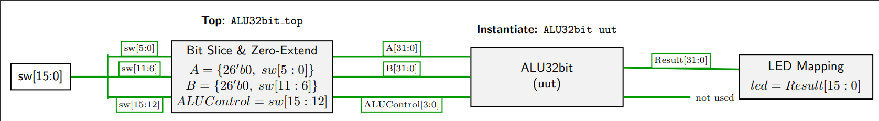

Task 2: Verilog Description and Testbench Development

Verilog source file for Register File

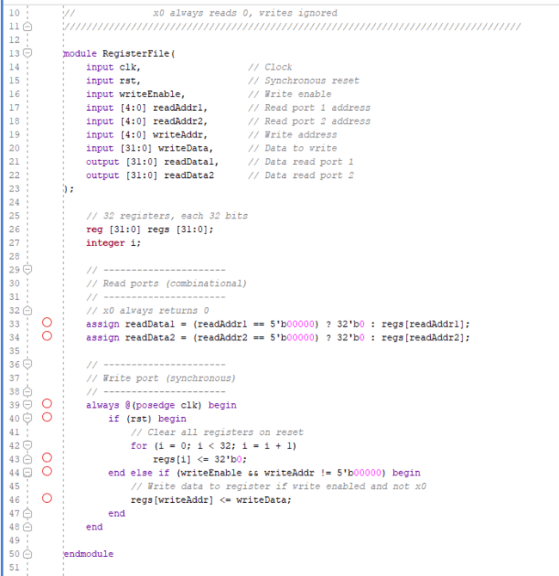

TEST BENCH CODE:
`timescale 1ns / 1ps
//////////////////////////////////////////////////////////////////////////////////
// Company:
// Engineer:
//
// Design Name: RF + ALU + FSM Testbench
// Module Name: RF_ALU_FSM_tb
// Description: Thorough testbench that writes multiple registers,
// performs multiple ALU operations, prints all signals
//////////////////////////////////////////////////////////////////////////////////

module RF_ALU_FSM_tb;

// Clock and reset
reg clk;
reg rst;

// Register File signals
reg writeEnable;
reg [4:0] rs1, rs2, rd; // read/write addresses
reg [31:0] writeData;
wire [31:0] readData1, readData2;

// ALU signals
reg [3:0] ALUControl;
wire [31:0] ALUResult;
wire Zero;
reg [31:0] A, B; // ALU inputs

// FSM state definition
reg [3:0] state;
localparam IDLE = 0,
WRITE_REGS = 1,
ALU_OP = 2,
WRITE_ALU_RES = 3,
NEXT_ALU_OP = 4,
DONE = 5;

integer i;

// Instantiate Register File
RegisterFile RF(
.clk(clk),
.rst(rst),
.writeEnable(writeEnable),
.readAddr1(rs1),
.readAddr2(rs2),
.writeAddr(rd),
.writeData(writeData),
.readData1(readData1),
.readData2(readData2)
);

// Instantiate ALU
ALU32bit ALU(
.A(A),
.B(B),
.ALUControl(ALUControl),
.ALUResult(ALUResult),
.Zero(Zero)
);

// Clock generation: 10ns period
initial clk = 0;
always #5 clk = ~clk;

// Arrays of test data
reg [31:0] regValues [1:10]; // Values to write
reg [4:0] regDest [1:10]; // Destination registers
reg [3:0] aluOps [0:7]; // ALU operations

initial begin
// Example register values
regValues[1] = 32'h10101010;
regValues[2] = 32'h01010101;
regValues[3] = 32'h00000005;
regValues[4] = 32'hFFFFFFFF;
regValues[5] = 32'h0000FFFF;
regValues[6] = 32'hAAAA5555;
regValues[7] = 32'h12345678;
regValues[8] = 32'h87654321;
regValues[9] = 32'h0F0F0F0F;
regValues[10] = 32'hF0F0F0F0;

// Destination registers to write ALU results
regDest[1] = 4;
regDest[2] = 5;
regDest[3] = 6;
regDest[4] = 7;
regDest[5] = 8;
regDest[6] = 9;
regDest[7] = 10;
regDest[8] = 11;
regDest[9] = 12;
regDest[10] = 13;

// ALU operations
aluOps[0] = 4'b0010; // ADD
aluOps[1] = 4'b0110; // SUB
aluOps[2] = 4'b0000; // AND
aluOps[3] = 4'b0001; // OR
aluOps[4] = 4'b0011; // XOR
aluOps[5] = 4'b0100; // SLL
aluOps[6] = 4'b0101; // SRL
aluOps[7] = 4'b0111; // SLT
end

// FSM sequence
reg [3:0] aluIndex;
reg [3:0] writeIndex;
always @(posedge clk or posedge rst) begin
if (rst) begin
state <= IDLE;
writeEnable <= 0;
rs1 <= 0; rs2 <= 0; rd <= 0;
writeData <= 0;
ALUControl <= 0;
writeIndex <= 1;
aluIndex <= 0;
end else begin
case(state)
IDLE: state <= WRITE_REGS;

// Write multiple registers
WRITE_REGS: begin
if (writeIndex <= 10) begin
writeEnable <= 1;
rd <= writeIndex;
writeData <= regValues[writeIndex];
writeIndex <= writeIndex + 1;
end else begin
writeEnable <= 0;
writeIndex <= 1;
state <= ALU_OP;
end
end

// ALU operations between x1 and x2 repeatedly
ALU_OP: begin
rs1 <= 1; rs2 <= 2;
A <= readData1; B <= readData2;
ALUControl <= aluOps[aluIndex];
state <= WRITE_ALU_RES;
end

WRITE_ALU_RES: begin
writeEnable <= 1;
rd <= regDest[aluIndex+1];
writeData <= ALUResult;
state <= NEXT_ALU_OP;
end

NEXT_ALU_OP: begin
writeEnable <= 0;
if (aluIndex < 7) begin
aluIndex <= aluIndex + 1;
state <= ALU_OP;
end else begin
state <= DONE;
end
end

DONE: begin
$display("Test Completed!");
$finish;
end
endcase
end
end

// Monitor all outputs
initial begin
$monitor("Time=%0t | State=%0d | rs1=%0d rs2=%0d rd=%0d | writeEn=%b | readData1=%h readData2=%h | A=%h B=%h | ALUResult=%h Zero=%b",
$time, state, rs1, rs2, rd, writeEnable, readData1, readData2, A, B, ALUResult, Zero);
end

// Waveform dump for GTKWave or ModelSim
initial begin
$dumpfile("RF_ALU_FSM_tb.vcd");
$dumpvars(0, RF_ALU_FSM_tb);
end

// Initial reset
initial begin
rst = 1;
#10 rst = 0;
end

endmodule

Verilog source file for Top-level (top rf alu.v).

`timescale 1ns / 1ps

module TOPmodule_registers(

input clk,

input rst,

input [15:0] switches,

output [15:0] leds

);

// ===============================

// WIRES

// ===============================

wire [31:0] readData1;

wire [31:0] readData2;

wire [31:0] ALUResult;

wire Zero;

reg writeEnable;

reg [4:0] writeAddr;

wire [31:0] writeData;

// ===============================

// CONSTANTS (for quick verification)

// ===============================

parameter CONST_A = 32'h10101010;

parameter CONST_B = 32'h01010101;

// ===============================

// WRITE ADDRESS CONTROL

// ===============================

always @(*) begin

case(switches[6:5])

2'b01: writeAddr = 5'd1; // load x1

2'b10: writeAddr = 5'd2; // load x2

2'b11: writeAddr = 5'd3; // store ALU result

default: writeAddr = 5'd0;

endcase

end

// ===============================

// WRITE ENABLE

// ===============================

always @(*) begin

writeEnable = switches[0];

end

// ===============================

// WRITE DATA MUX

// ===============================

assign writeData =

(switches[6:5] == 2'b01) ? CONST_A :

(switches[6:5] == 2'b10) ? CONST_B :

(switches[6:5] == 2'b11) ? ALUResult :

32'b0;

// ===============================

// REGISTER FILE

// ===============================

RegisterFile RF (

.clk(clk),

.rst(rst),

.writeEnable(writeEnable),

.readAddr1(5'd1), // always read x1

.readAddr2(5'd2), // always read x2

.writeAddr(writeAddr),

.writeData(writeData),

.readData1(readData1),

.readData2(readData2)

);

// ===============================

// ALU

// ===============================

ALU32bit ALU (

.A(readData1),

.B(readData2),

.ALUControl(switches[4:1]),

.ALUResult(ALUResult),

.Zero(Zero)

);

// ===============================

// LED OUTPUT

// ===============================

assign leds[15] = Zero; // show Zero flag

assign leds[14:0] = ALUResult[14:0]; // show result LSBs

endmodule

Testbench file for Top-level

`timescale 1ns / 1ps

module TOPmodule_registers_tb;

reg clk;

reg rst;

reg [15:0] switches;

wire [15:0] leds;

// Instantiate DUT

TOPmodule_registers DUT (

.clk(clk),

.rst(rst),

.switches(switches),

.leds(leds)

);

// Clock generation (10ns period)

always #5 clk = ~clk;

// =============================

// TASK: Perform a write

// =============================

task write_operation;

input [1:0] addrSel;

begin

switches[6:5] = addrSel; // select x1, x2, or x3

switches[0] = 1; // write enable

@(posedge clk);

#2 switches[0] = 0; // disable write

end

endtask

// =============================

// TASK: Perform ALU operation

// =============================

task alu_operation;

input [3:0] aluCtrl;

begin

switches[4:1] = aluCtrl;

@(posedge clk);

#2;

$display("TIME=%0t | ALUControl=%b | LEDS=%h | ZERO=%b",

$time, aluCtrl, leds, leds[15]);

end

endtask

// =============================

// TEST SEQUENCE

// =============================

initial begin

$display("===== STARTING SIMULATION =====");

clk = 0;

rst = 1;

switches = 0;

#20;

rst = 0;

// -----------------------------

// Load CONST_A into x1

// -----------------------------

$display("Loading CONST_A into x1");

write_operation(2'b01);

// -----------------------------

// Load CONST_B into x2

// -----------------------------

$display("Loading CONST_B into x2");

write_operation(2'b10);

// -----------------------------

// ALU OPERATIONS

// -----------------------------

alu_operation(4'b0010); // ADD

alu_operation(4'b0110); // SUB

alu_operation(4'b0000); // AND

alu_operation(4'b0001); // OR

alu_operation(4'b0011); // XOR

alu_operation(4'b0111); // SLT

// -----------------------------

// Store ALU result into x3

// -----------------------------

$display("Storing ALU result into x3");

write_operation(2'b11);

#50;

$display("===== SIMULATION FINISHED =====");

$stop;

end

endmodule

Simulation waveforms showing correct operation

ALU OPERATION BITS:
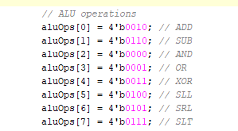

Expected Results:
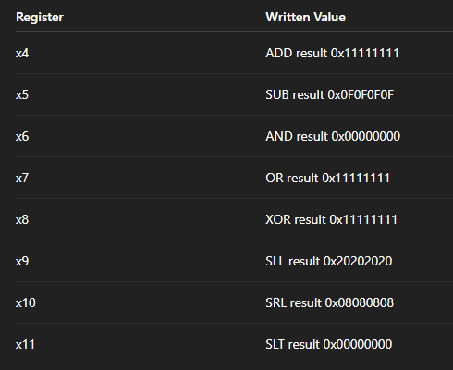

WAVEFORMS:

When NO VALUES ARE ADDED TO REGISTERS FOR ALU INPUTS: (A, B; Both has value of zero)
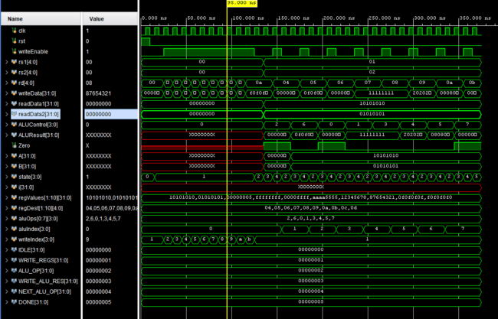

AFTER WRITE DATA IS TURNED ON THE HARD CODED VALUES GET SAVED IN READ DATA1, READ DATA2
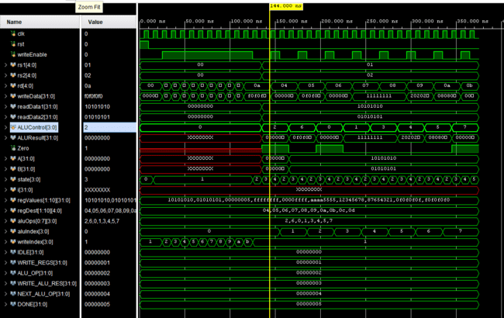

WHEN ALU CONTROL=0, THAT MEANS IT SHOULD PERFORM AND:
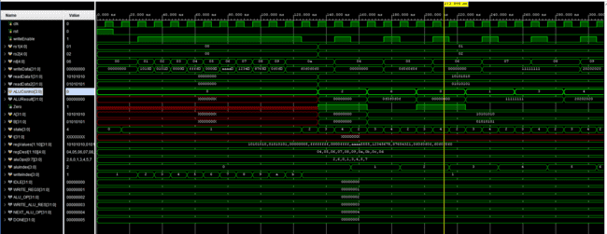

When ALU CONTROL=1, THAT MEANS IT SHOULD PERFORM OR:
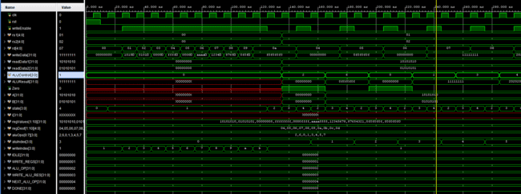

WHEN ALU CONTROL=5, THAT MEANS IT SHOLD PERFORM SRL:
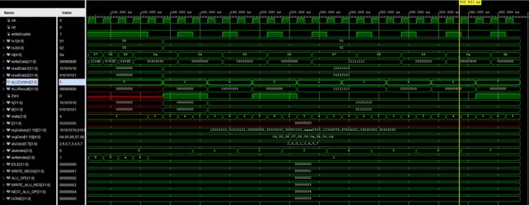

WHEN ALU CONTROL=7, THAT MEASN IT SHOULD PERFORM SLT:
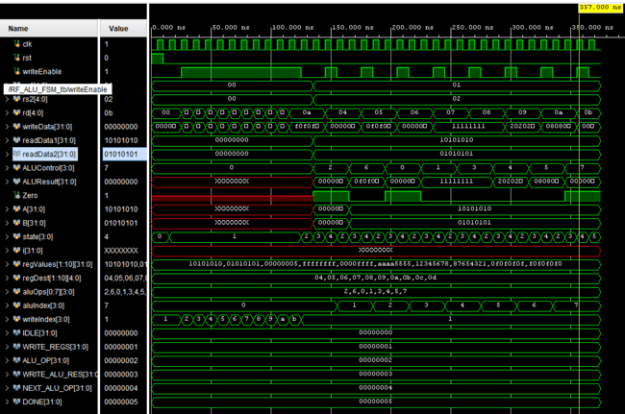

REST CASES ARE ALSO DONE SAME WAY…..

Task 3: FPGA Synthesis and RTL Analysis
Note: The switch interface, button debouncing module, and LED interface must be re used from Lab 5.

RTL schematic screenshots (register file array, decoder, FSM, ALU connections)

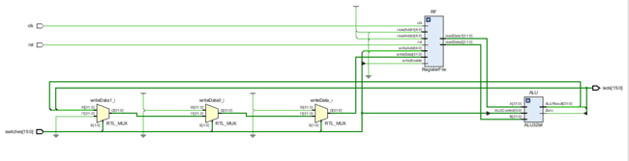

Demonstration of FPGA operation

VALUE STORD IN A= 0X10101010

B=0X01010101

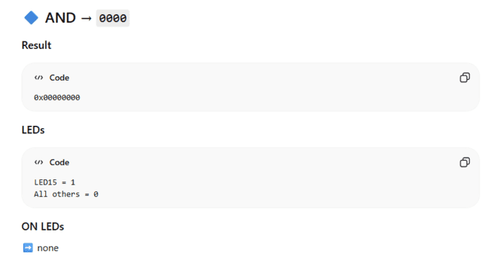

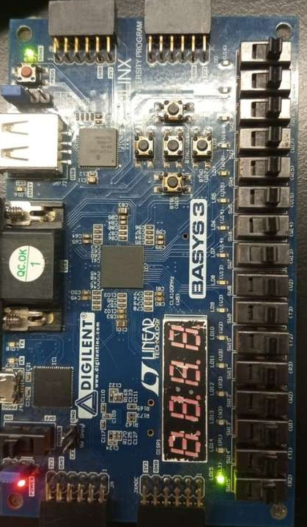

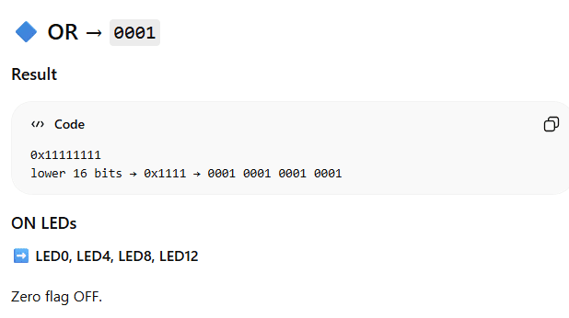

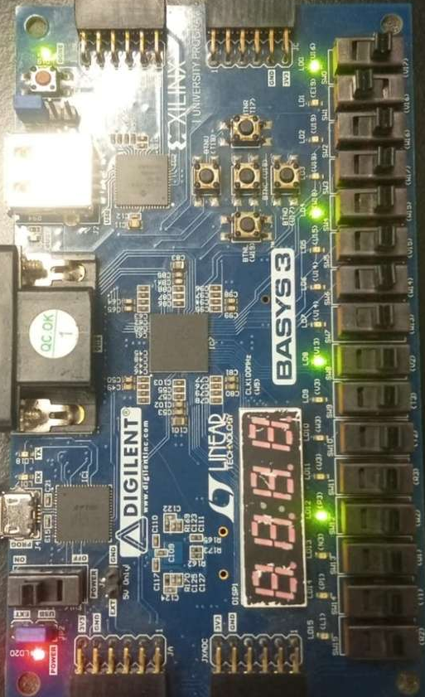

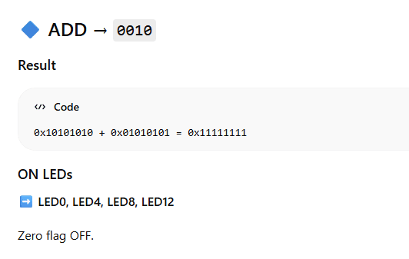

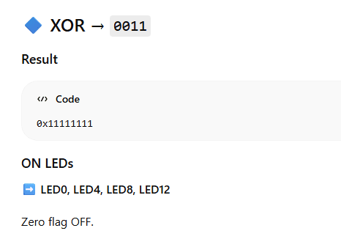

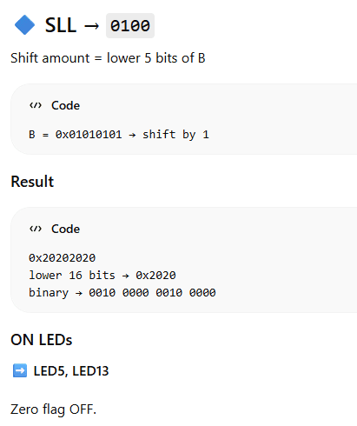

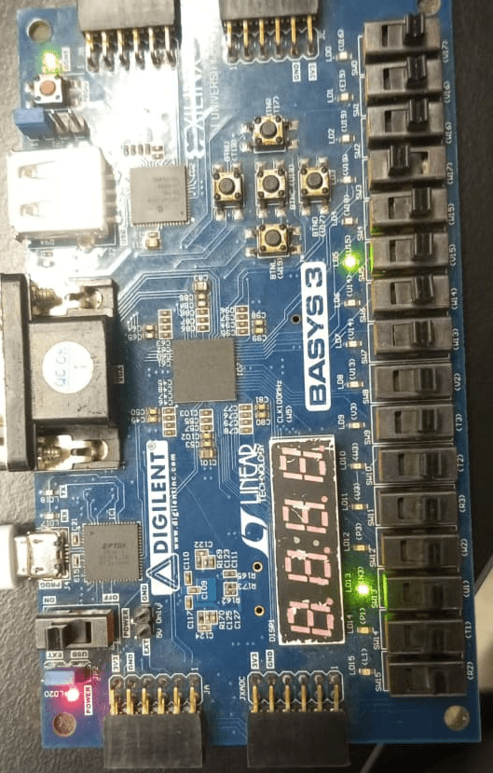

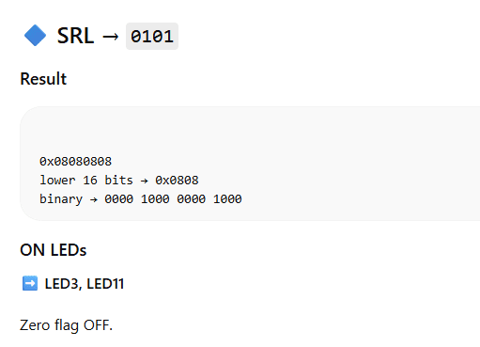

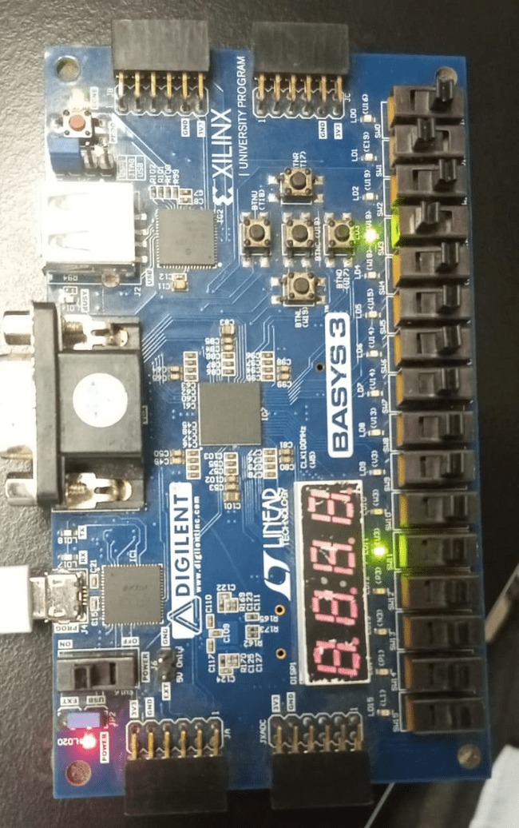

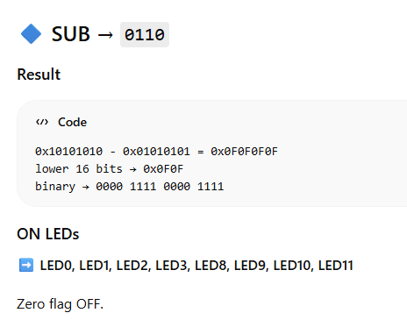

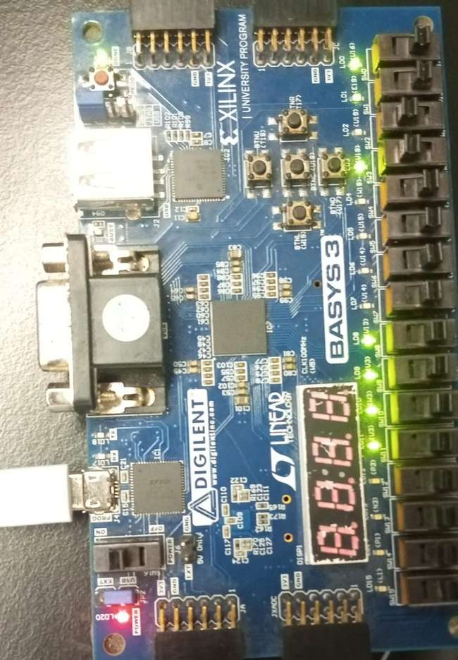

NOTE: THE 2 LED’S WHCH ARE NOT WORKING LED: 1, 2; WERE LIGHLTLY LIT BT WERE NO CAPTURED IN THE PICTURE.

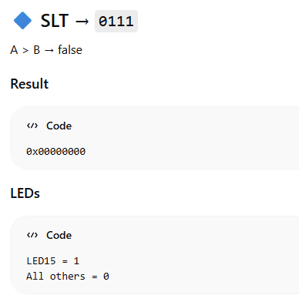

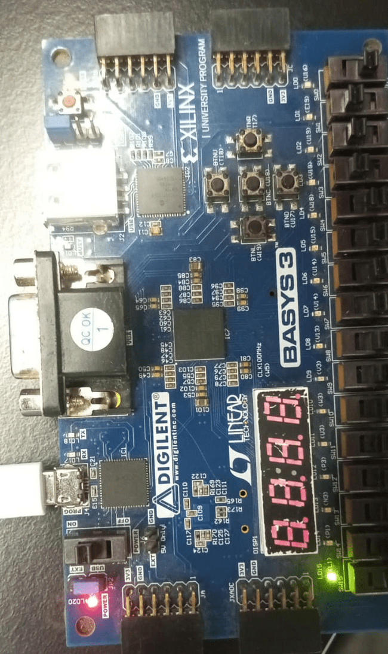

Assessment Rubric
Lab 7: Design and FPGA Implementation of the Register File for a Single-Cycle RISC-V Processor

Name: | Student ID: | Section:

Points Distribution

 | Task No. | LR 2 (Code) | LR 5 (Results) | LR 11  (Design)
In-Lab | Task 1 | - | - | /10
In-Lab | Task 2 | /20 | /10 | -
In-Lab | Task 3 | /20 | /20 | -
Total Points |  | /40 | /30 | /10
CLO Mapped |  | CLO 1

Affective Domain Rubric |  | Points | CLO Mapped
AR7 | Report Submission & Git Upload | /10 & /10 | CLO 1

CLO | Total Points | Points Obtained
1 | 100
Total | 100

For description of different levels of the mapped rubrics, please refer to the Lab Evaluation Assessment Rubrics and Affective Domain Assessment Rubrics provided here.

